Reading Water Meters
June 2016
The City has begun to read meters! The below image is what should appear on your statement this month. If you have your service turned off, you should see a zero under the column marked “Currently Unmetered”.

On May 2, 2016 your meters were read, and again on May 31st to get an initial usage amount. Please take note of the total usage in the column labeled “Currently Unmetered”. If your usage is high (over 7500 gallons), we ask that you please look for leaks, and really look at how you utilize your water. Things that could cause your usage to be high would be watering your lawn all day, washing vehicles, filling hot tubs, filling the bathtub frequently, or watering gardens and greenhouses. If you think you may have a leak, please try and get it fixed as soon as possible, if you are not sure and need help, please call the city hall.

Eventually, water billing will be moved to a flat rate with an overage charge dependent on how many gallons of water are being used monthly. However, we want to give everyone ample time to fix any leaks they may have, and figure out other ways to conserve water usage so billing will remain the same for the time being.

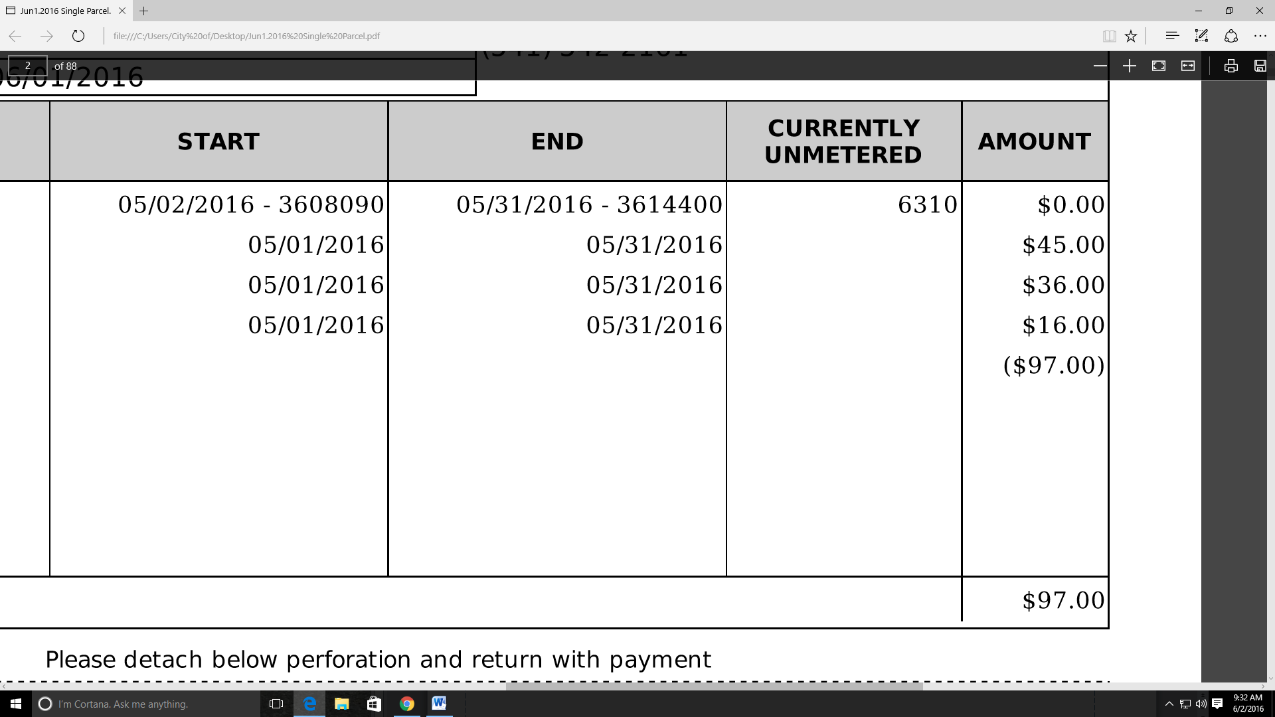

Beginning Month Meter Reading

Total Monthly Usage in Gallons

End Month Meter Reading

Yes, please sign me up for e-billing!

I understand I will no longer receive paper statements in the mail and will be e-mailed my statements and newsletters.

E-mail address:

